ABSTRACT
The Smart Voting System Using Blockchain, Fingerprint, and Face Recognition is a secure and innovative approach to enhance the integrity of voting processes. By leveraging blockchain technology for data storage, fingerprint-based authentication, and facial recognition for identity verification, the system ensures robust security and transparency. The application is divided into two modules: the admin module for managing the voting process and the voter module for securely casting votes. This system provides a seamless and tamper-proof mechanism for conducting elections, ensuring trustworthiness and accessibility.

Existing System
Traditional voting systems often rely on manual processes, electronic voting machines, or online portals without advanced security mechanisms. These systems are susceptible to issues like vote tampering, unauthorized access, and identity fraud. Moreover, the centralized storage of voting data increases the risk of data breaches, compromising the confidentiality and integrity of election results.
Disadvantages:
- Vulnerability to hacking or tampering due to centralized data storage.
- Lack of advanced mechanisms for identity verification, increasing the risk of fraud.

Proposed System
The proposed Smart Voting System combines blockchain technology with fingerprint and facial recognition to ensure a secure, decentralized, and transparent voting process. The system enables voters to register with their biometric and facial data, which is stored on the blockchain for immutable record-keeping. During voting, the system verifies the voter's fingerprint and facial identity before allowing them to cast their vote, thereby eliminating unauthorized access and identity fraud.
Advantages:
- Enhanced security through decentralized blockchain storage, making data tamper-proof.
- Biometric and facial recognition mechanisms ensure accurate voter authentication, reducing fraud.
SYSTEM REQUIREMENTS
HARDWARE REQUIREMENTS:

- System : Pentium Dual Core.
- Hard Disk : 120 GB.
- Monitor : 15’’ LED
- Input Devices : Keyboard, Mouse
- Ram : 1 GB

SOFTWARE REQUIREMENTS:

- Operating system : Windows 11.
- Coding Language : python
- Tool : Pycharm
- Database : MYSQL
- framework : Django
- Technologies : pdbc, blockchain
- Front-end : html,css

ARCHITECTURE
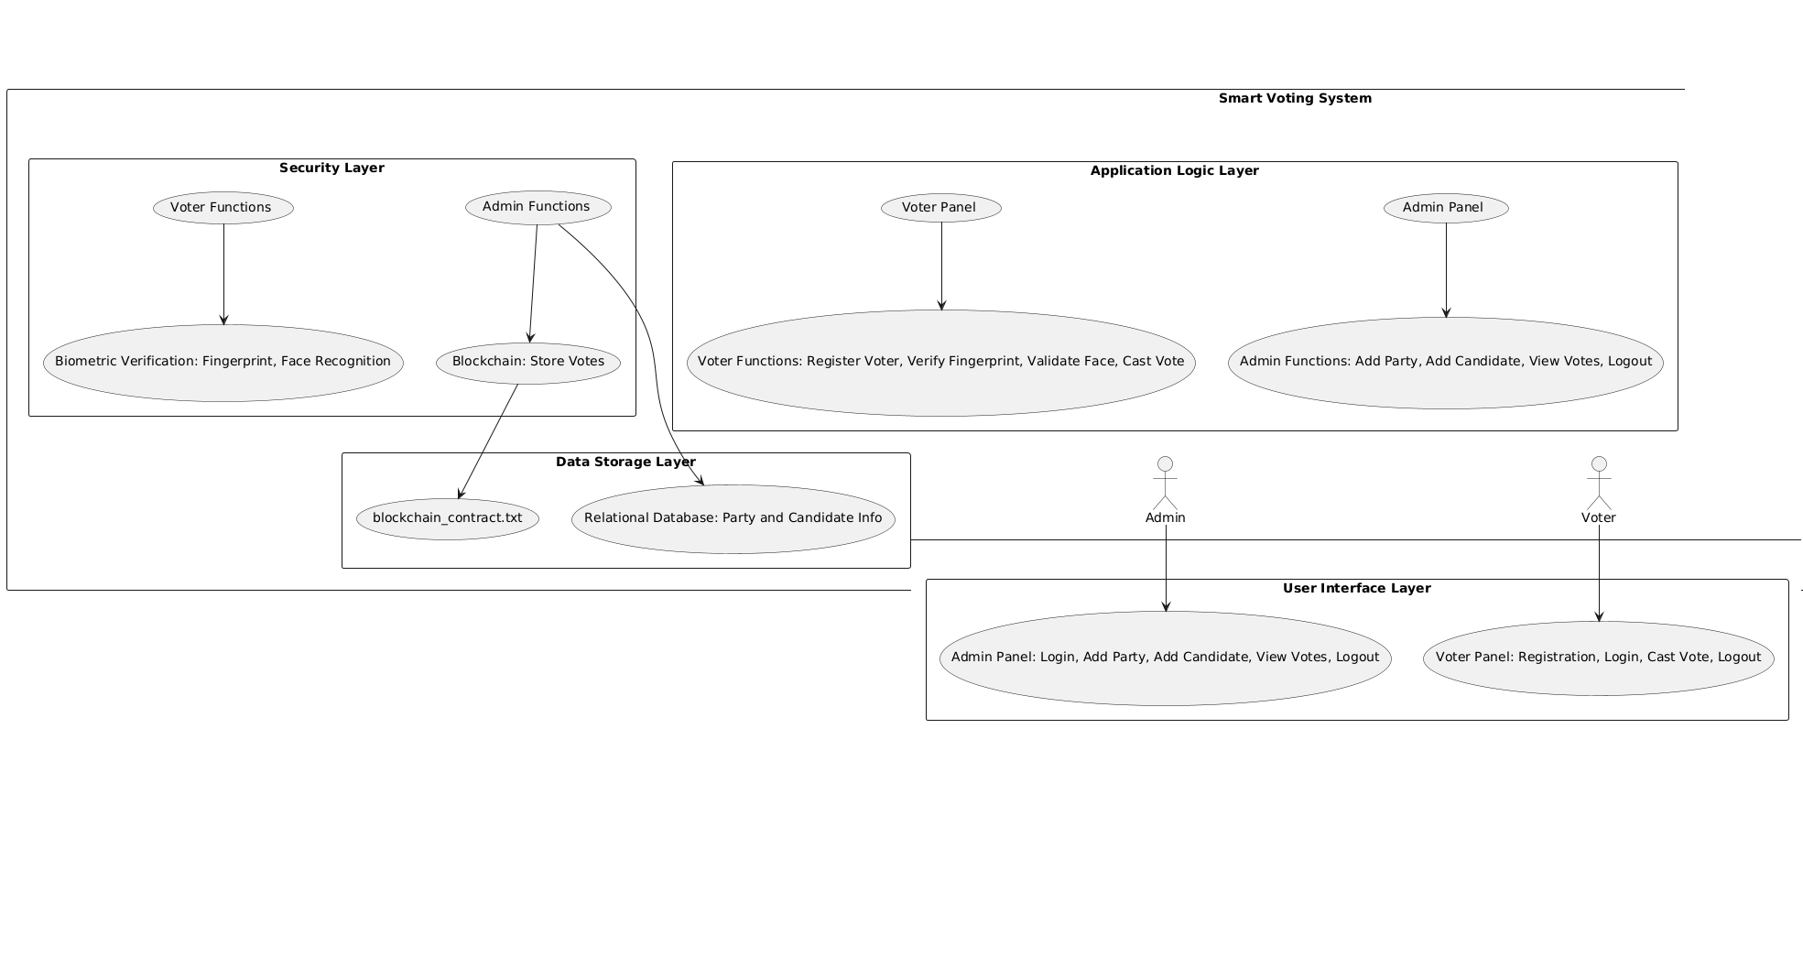

Conclusion
The Smart Voting System Using Blockchain, Fingerprint, and Face Recognition successfully addresses the challenges of traditional voting systems by ensuring security, transparency, and voter authenticity. By combining blockchain's decentralized storage with advanced biometric verification methods, the system provides a reliable solution for conducting fair and fraud-proof elections. This innovative approach paves the way for future advancements in secure digital voting systems, contributing significantly to the evolution of democratic processes.

References
- Nakamoto, S. (2008). Bitcoin: A Peer-to-Peer Electronic Cash System.
- Schneier, B. (2015). Applied Cryptography: Protocols, Algorithms, and Source Code in C.
- Face Recognition Library Documentation - https://face-recognition.readthedocs.io/
- Django Documentation - https://docs.djangoproject.com/
- Blockchain Basics - https://blockgeeks.com/guides/what-is-blockchain-technology/
- Rossum, G. (2009). Python Programming Language. Python Software Foundation.
- He, K., Zhang, X., Ren, S., & Sun, J. (2015). Deep Residual Learning for Image Recognition. IEEE Conference on Computer Vision and Pattern Recognition (CVPR).
- Goodfellow, I., Bengio, Y., & Courville, A. (2016). Deep Learning. MIT Press.
- Zhao, J., Cui, W., Qian, L., & Xue, F. (2017). Blockchain Technology in Voting Systems: Research and Application. Journal of Emerging Technologies in Computing Systems.
- Kaur, G., & Saini, J. R. (2019). Biometric Authentication in Secure Voting Systems. International Journal of Engineering Research and Technology.

